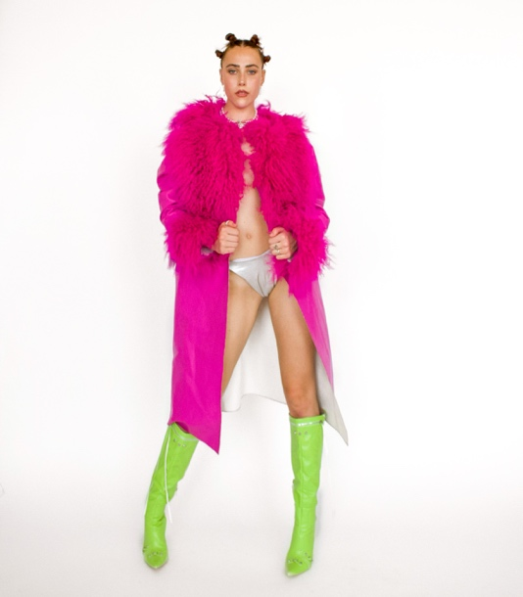Millie Gallimore

REPRESENTED BY AMCK DANCE, AJK AGENCY, ASH TALENT, DANCE FUSION, SUZETTE BRISSETT CREATIVES.

Email: milliegallimorea@outlook.com

PHONE: 07920142157

Instagram: @milliegallimore_

pERSONAL INFORMATION

AGE - 21

HEIGHT – 5’7”

hair – BROWN

eyes – blue

SHOE – 6UK

DRESS – 8UK

WAIST – 26”

HIPS – 36”

INSEAM – 33’

COLLAR – 12.5”

CHEST – 32”

credits: becky hill, raye, jax jones, ANNIE MAC, The ktna, sports direct, pepsi max AND MORE.

**STAGE/LIVE PERFORMANCE**

One Young World Summit 2022 – Dancer | Choreography: Nikki Trow, Stevie Mahoney | Production: Private Drama Events

Commonwealth Games 2022 – Dancer | Choreography: Aicha Mckenzie, Shaun Niles, Josh Wharmby | Production: AMCK Dance

Upfront London 2022 – Dancer | Choreography: Ainsley Ricketts

Move It London 2022 – Dancer | Choreography: Leroy Curwood

Annie Mac – Warehouse Project 2021 – Dancer | Choreography: Ellis Brownhill | Production: ABF Entertainment

Parklife Promo – Tyler the Creator – Dancer | Choreography: Yasmin Harcourt

Look Fantastic Event – Freestyle | Production: The Social PR

**FILM/TV**

Scuh x Dr. Martens TV Commercial 2023 – Featured Dancer

Heretic Nine Clothing Social Campaign 2023

King O’Holi – FLO Submission 2023 – Featured Dancerp

Pepsi Max TV Commercial 2022 – MO SALAH ‘STAY THIRSTY 2.0’ Campaign - Dancer

Sports Direct TV Commercial / Social Campaign 2021 – ‘DON’T STOP MOVING!’ | Production: MOX London – Dancer

Lazy Oaf Social Campaign – Dancer

Chiara Kanem | Music Video 2021 – Dancer

**PROFESSIONAL TRAINING AND QUALIFICATIONS**

BA Hons in Professional and Commercial Dance – Shockout Arts | Rewarded with 1st class honours - 2022

Camera Ready Intensive 2023 – Lisa Spencer

Space To Create 2022 / 2023 – King O’Holi

P:SG Training Program – Sisco Gomez

Made By June Private Session 2021 – Sharon June

Runway House Dance Programme 2019

K.I.M Intensive – Kim Taylor